1. Which are the top three variables in your model which contribute most towards the probability of a lead getting converted?

Answer-

Based on the coefficient values from below screenshot, the following are the top three variables that contribute most towards the probability of a lead getting converted :

a) Total Time Spent on Website

b) Lead Add Form (from Lead Origin)

c) Working Professional ( From Current Occupation)

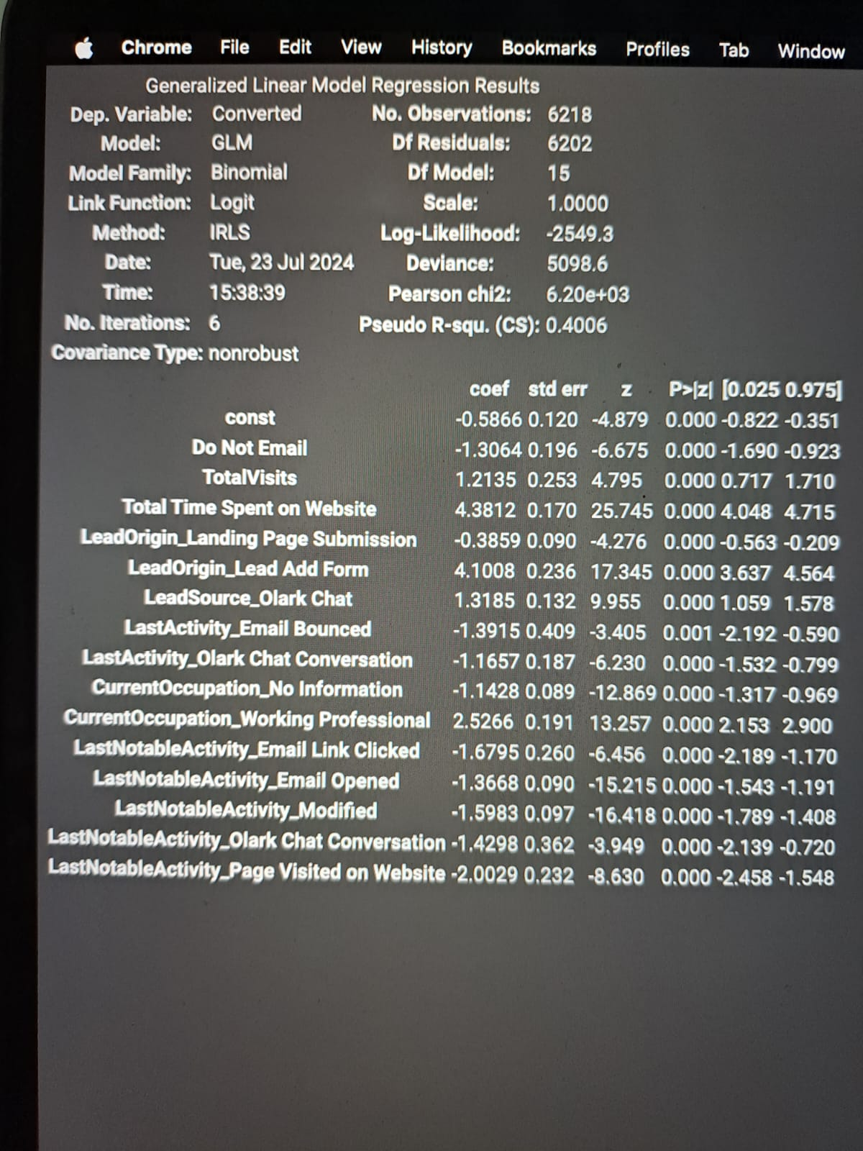

1. What are the top 3 categorical/dummy variables in the model which should be focused the most on in order to increase the probability of lead conversion?

Answer-

Again, based on the coefficient values from the screen shot in the question above, the following are the top three categorical/dummy variables that should be focused the most in order to increase the probability of lead conversion :

a) Total Time Spent on Website

b) Lead Add Form (from Lead Origin)

c) Working Professional ( From Current Occupation)

1. X Education has a period of 2 months every year during which they hire some interns. The sales team, in particular, has around 10 interns allotted to them. So during this phase, they wish to make the lead conversion more aggressive. So they want almost all of the potential leads (i.e. the customers who have been predicted as 1 by the model) to be converted and hence, want to make phone calls to as many of such people as possible. Suggest a good strategy they should employ at this stage.

Answer:

In the below image, the final prediction is calculated based on a optimal cut off value of

0.37. In order to make the sales aggressive, the company may contact all the leads which have a conversion probability (value = 1) under a cut off 0.2

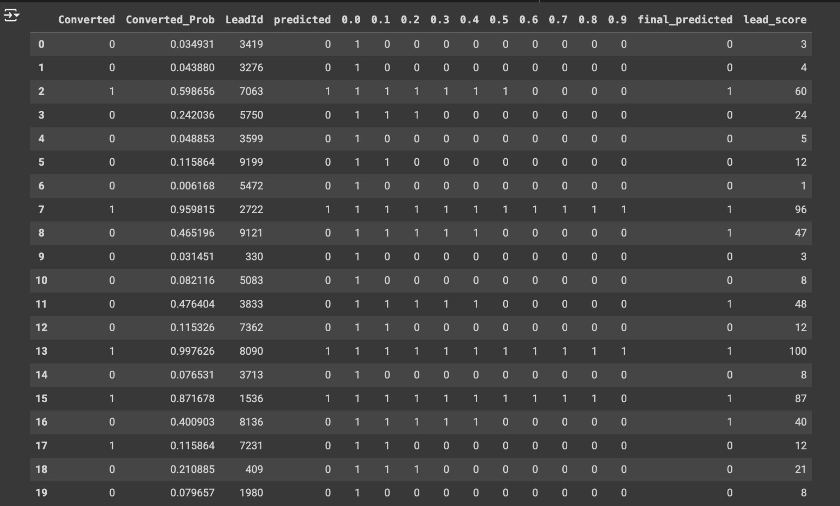

1. Similarly, at times, the company reaches its target for a quarter before the deadline. During this time, the company wants the sales team to focus on some new work as well. So during this time, the company’s aim is to not make phone calls unless it’s extremely necessary, i.e. they want to minimize the rate of useless phone calls. Suggest a strategy they should employ at this stage.

Answer: **Strategy: Focus on High Probability Leads**

1. **Set a High Threshold for Conversion Probability**:
   * From the provided data, it appears that the Converted_Prob column indicates the probability of conversion. Leads with a higher conversion probability should be prioritized.
   * For example, the company could set a threshold such as only calling leads with a Converted_Prob of 0.8 or higher. This ensures that only the leads most likely to convert are contacted, thereby minimizing the rate of useless phone calls.
2. **Utilize the final_predicted Column**:
   * The final_predicted column seems to indicate whether the lead is predicted to convert (1) or not (0). Focus on contacting leads where final_predicted is 1.
   * This could be a secondary check to ensure that the leads being called have been identified by the model as having a high probability of conversion.
3. **Leverage lead_score for Prioritization**:
   * The lead_score column can be used to further prioritize leads. Higher scores should be given precedence, as they likely indicate a higher chance of conversion or a more valuable lead.
   * For example, if two leads have a Converted_Prob above 0.8, but different lead_score, prioritize the one with the higher score.

